Chapter 23
Exploiting Endophytes
The widespread occurrence of endophytic organisms that form mutualistic associations with their plant hosts offers new opportunities for agriculture. Manipulating a plant's endophyte community may enhance resistance to abiotic and biotic stress, improve immunity to pathogens and insect pests, promote plant growth in various ways, and even enhance end-product quality by altering the plant phenotype (Fig. 1). Although not fully understood, farmers can use microbial sprays to modify the Cannabis plant’s microbiome, potentially improving certain aspects of its growth. Broad-spectrum, nonspecific inoculations of epiphytes and endophytes occur whenever a grower applies a foliar spray containing microbial solutions, such as compost tea or other microbial food sources. With accessible technology and knowledge, growers can advance this practice by selectively choosing the microbes included in inocula applied to crops.
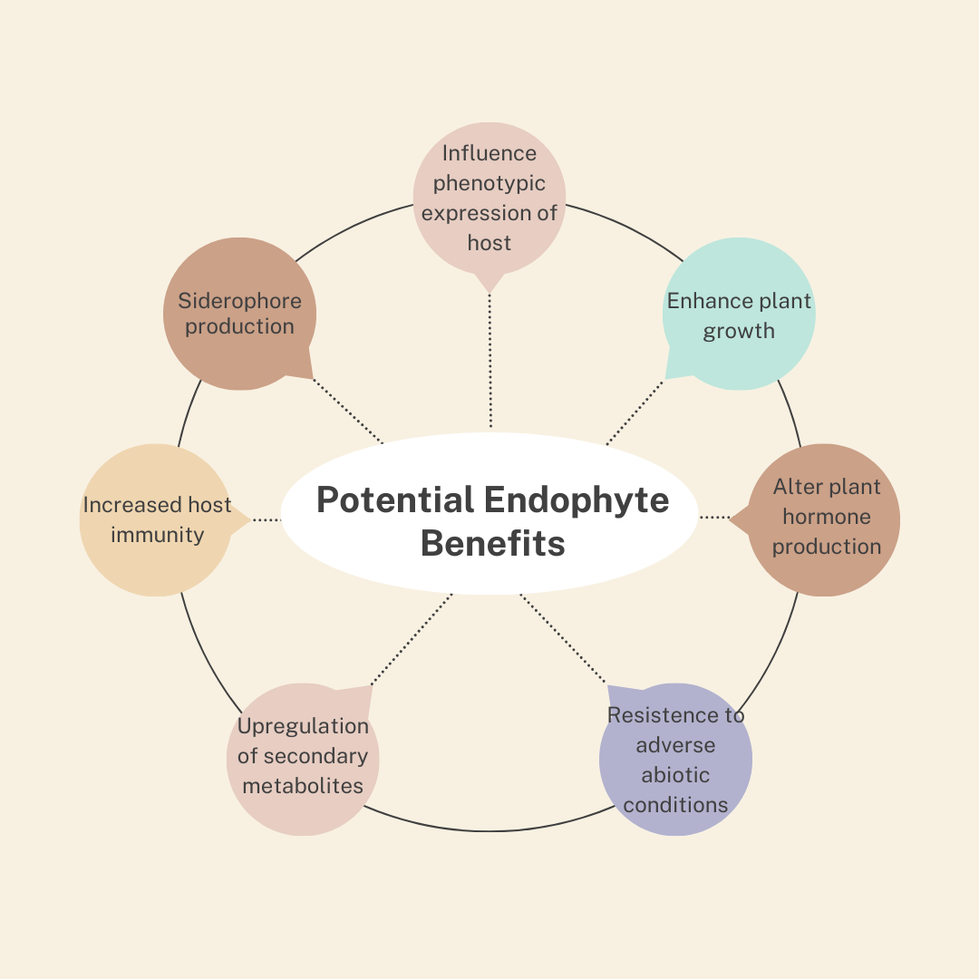
Figure 24.1. Some of the potential benefits that fungal endophytes may confer to agricultural crops, including Cannabis sativa.

Some selectivity can be imposed when preparing compost tea by adjusting starting materials and brewing conditions (e.g., time, temperature, and oxygen levels). Specific microbial inocula or products may be added to introduce beneficial species. By working with endophytes, growers can select microbes capable of forming symbiotic, internal relationships with Cannabis.
Endophytes found within healthy Cannabis plants represent a reservoir of potential beneficial mutualists. However, latent parasites may also exist within Cannabis. Therefore, isolating an endophyte from healthy Cannabis tissue does not guarantee it is a mutualist. Endophytes can be screened and reapplied, alone or in combination, to manipulate plant health and behavior.

Endophyte Isolation
Isolating endophytes requires relatively simple materials and tools (see protocols at the end of this chapter). A sterile laboratory environment is highly recommended to prevent contamination. Laminar flow hoods can provide a clean workspace, though biosafety cabinets are preferred since some endophytes may be human pathogens. If these are unavailable, still-air boxes and dedicated clean rooms can improve success rates. Wearing an N95 mask or higher while working and increasing room ventilation reduces the risk of inhaling pathogen spores.
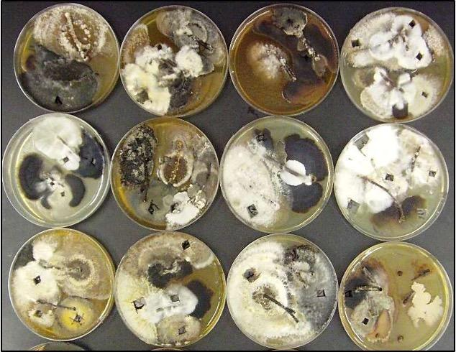
Figure 24.2. Endophytes being isolated from stem sections of American Chestnut on PDA.
Endophytes emerge directly from plant tissue (Fig. 2). While it is easy to discard contaminants growing away from the plant tissue on a culture plate, those growing near plant tissue may be difficult to distinguish from true endophytes. Many contaminant molds can also function as endophytes, making sterile culture techniques essential. Control plates should be included to monitor contamination. The goal of these procedures is to isolate beneficial endophytes from plant tissue (Fig. 3). Any endophyte found within Cannabis tissue inherently has the ability to infect and persist within a Cannabis plant. Using healthy Cannabis tissue reduces the likelihood of isolating harmful endophytes.
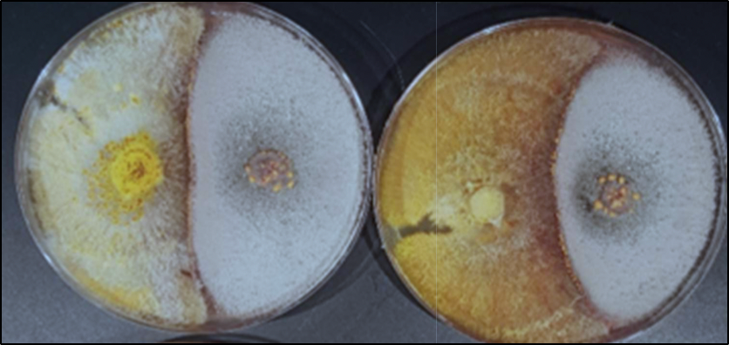
Figure 24.3. Dual culture assay of an endophyte vs a plant pathogen plated on PDA to determine if the endophyte offers protection to the plant from the pathogen (Cryphonectria parasitica on the left).

The selection of plant material for endophyte isolation is crucial. Outdoor plants will likely have different endophyte populations than indoor plants. Geographic location and land use patterns influence endophyte populations, especially for outdoor plants. There is growing interest in landrace and feral genetics from ancient areas of Cannabis cultivation, as their endophytes have coevolved naturally with Cannabis. Additionally, cultivar genotype and tissue type are key factors in determining endophyte populations and subsequent isolations.

Isolate Identification
Endophytes can be difficult to identify morphologically, as many do not form fruiting structures in culture, which are typically necessary for accurate identification. Even with molecular techniques, many endophytes remain undescribed, and genomic databases are incomplete. While precise identification is not always required, it is important to be aware of the risk of isolating and amplifying latent pathogens. Some common endophytes, such as Aspergillus niger, a species of concern as a human pathogen, do produce diagnostic cultures and spores (usually asexual conidia) that can be readily identified.
Dual-culture assays provide a simple method for evaluating an endophyte's ability to antagonize specific pathogens (Fig. 4). While plant-host-mediated interactions are not accounted for, these assays can help assess an endophyte’s potential benefits. Endophytes can be tested against various pathogens or specific threats relevant to the grower’s conditions.
To perform dual-culture assays, plates with media are inoculated equidistantly with a pathogen and an endophyte (see the protocol at the end of this chapter). The organisms are allowed to interact, and the results are observed and measured. Evaluations can include quantitative assessments, such as culture size ratios, and qualitative observations, such as pigmentation and inhibition zones.

Endophyte Consortia
Applying endophytes as consortia may be more effective than using individual isolates in agriculture (Carroll, 1991). Endophytes can be isolated and recombined in specific proportions or mass-cultured from plant tissue without selection. If first isolated, they may be screened for beneficial properties before being recombined into an agricultural inoculum.

In Planta Testing
Any endophyte inoculum developed should be tested on a small group of plants before widespread application. Although the risk is low when applying Cannabis-indigenous endophytes to Cannabis plants, it is essential to confirm they do not cause harm. Sound experimental design and statistical analysis should be used to evaluate the efficacy of endophyte treatments in real-world conditions. Endophytes interact differently with various host cultivars and across different environments. While farmer-isolated endophytes may offer unique benefits suited to specific growing systems where commercial inocula cannot, their development and application can be time- and resource-intensive.
Protocols for endophyte extraction, isolation, and dual culture assays
Materials needed:
- 95% ethanol (Everclear)

- Household bleach (5.25% v/v)

- Scalpels, clippers if necessary.

- Prepared plates with desired media. Standard Potato Dextrose Agar (PDA) is acceptable. Malt Extract Agar (MEA) is also widely available and will work. Differences in media may affect endophyte recovery by favoring or disfavoring species based on growth preferences. Antibacterial additives (streptomycin, tetracycline, chloramphenicol, rose bengal, ect) may be added to select against bacteria and for fast growing fungi.

- A clean working lab space with a lamp, burner, bactoincinerator, or glass bead sterilizer.

Extraction protocol:

- Cut desired sections of plant tissue into manageable sections and surface sterilize them by serially submerging each in 95% ethanol for 30 seconds, a sodium hypochlorite solution (5.25% v/v) for 3 minutes, 75% ethanol for 30 seconds, followed by sterile, distilled water for 30 seconds.

- Plate each piece of tissue on clean plates of media. To ensure the adequacy of your surface sterilization procedures, imprint each piece of tissue onto a media plate before moving it to its growth plate, and/or plate aliquots of the sterile rinse water. If organisms grow on the imprint or aliquot plates, the plates with the relevant plant tissue should also be assumed contaminated with non-endophytes. Seal plates with parafilm and incubate at room temperature in a dark place. Plates should be stored upside down during incubation to prevent condensation from dripping onto cultures.

- As endophytes emerge from the plant tissue, individual colonies should be cut out and re-plated on new media plates to isolate individuals. It is important to monitor plates closely and perform isolations as soon as possible; some fungi will quickly outcompete others in culture. Endophytes are highly diverse within small tissue samples. Reducing the size of tissue sections to be plated may increase recovery of slow growing isolates.

Qualitative screening method protocol:
Qualitative analysis allows a large number of endophytes to be screened for activity and is not prone to variations in growth speed of isolates in vitro that may not reflect in planta activity.

- Endophytes can be scored based on their ability to (A=1) deadlock in culture, (B=2) deadlock at a distance, (C=3) partially overgrow the blight fungus, or (D=4) completely overgrow the pathogen with replacement by the endophyte. The same values are assigned as negatives in the cases where the pathogen outcompeted the candidate endophyte. Positive values in any of these categories indicate antagonism, with A-type considered the least strong, B-type intermediate (indicative of possible excretion of antimicrobials), and C- and D-types the strongest.

- A single numerical antagonism index (AI) may be assigned to each endophyte, calculated with formula: AI = [A (n×1) + B (n×2) + C (n×3) + D (n×4)] / N; Where n= the frequency of each interaction type between a particular endophyte and the pathogen, and N= the total number of replicates performed for each pairing. A specific point, based on time or extent of culture growth, may be set at which to calculate AI for comparison among numerous candidate endophytes.

- Characterize the top performing endophytes and devise inoculation mechanisms appropriate for their biology (i.e. Are they safe species for humans to work with? How easily are they cultured? Do they produce spores in culture? Are applied inocula preparations effective at introducing the organism into new host plants?).

Suggested mass culture protocol:
- Sterilize plant tissue sections as described above (Endophyte isolation).

- Following sterilization, rather than plating tissue sections onto solid agar media, drop them into flasks of liquid media and place on a stir plate or shaker table. Endophytes will emerge into the liquid media in a nonselective manner. You will not have selective control over the population of the resulting slurry of endophytes, which may be prone to domination by the fastest or most aggressive individuals or species. Additions may be added, such as rose bengal, which may broaden the species recovered from plant samples by slowing the growth among aggressive species.

- Dilute and apply mycelial suspension onto desired plant parts of the target crop plants. Specific inocula density can be standardized by measuring the density of the original culture (hyphae or spores) using a slide with a counting-chamber and diluting accordingly.

In summary:
- Cannabis plants contain communities of microorganisms inside of the plant tissue that do not cause any apparent harm. These organisms are referred to as endophytes.
- By applying microbial endophyte products to Cannabis plants growers can influence and enhance the plants microbiome which may improve plant fitness
- Endophyte inocula can be purchased or can be made on the farm

